CJLR ePSW User Manual

For Supplier

Revision History

|  |  |  |  |
| --- | --- | --- | --- |
| Version | Revision Date | Summary of Changes | Author |
| V 1.0 | 2018/09/20 | Draft | Liu An |

Content

Contents

Content 4

1. Business Process Introduction 5

1.1 Purpose 5

1.2 Process Description 5

2. CJLR ePSW Solution Manual Detail 6

2.1 Purpose 6

2.2 Prerequisites or special case 6

2.3 Transaction Code 6

2.4 Work Step 6

2.4.1 Login 6

2.4.2 PSW Introduction 7

2.4.3 Worklist 8

2.4.4 Partlist 13

2.4.5 Notification 17

# Business Process Introduction

## Purpose

The purpose is to introduce the business process related to CJLR ePSW for PD/STA .

## Process Description

Supplier is able to do below in CJLR ePSW:

* Create New PSW
* View PSW
* Work list
* Part list

# CJLR ePSW Solution Manual Detail

## Purpose

The purpose of this user manual is to describe the function detail of CJLR ePSW Application. CJLR PD/STA can take a reference.

## Prerequisites or special case

* **IE11, Firefox, Chrome is supported**
* **Firefox is recommended due to SRM**

## Transaction Code

N/A

## Work Step

### Login

1. Open Firefox and enter below URL:

<https://cjlr.portal.ap1.covapp.io/>

1. Log in to CJLR Portal with Supplier account
2. Select ePSW in CJLR Application

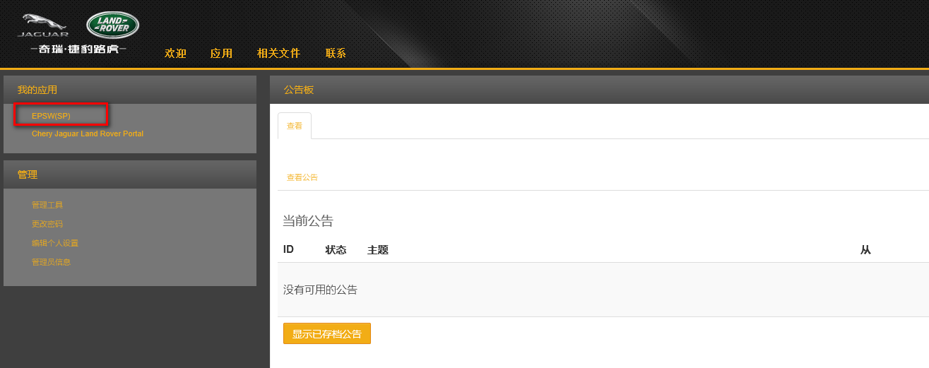

1. Click CJLR ePSW from My Applications, CJLR ePSW page displays

### PSW Introduction

* High Level Lifecycle Overview for PPAP Submission levels 2 - 5 inclusive.

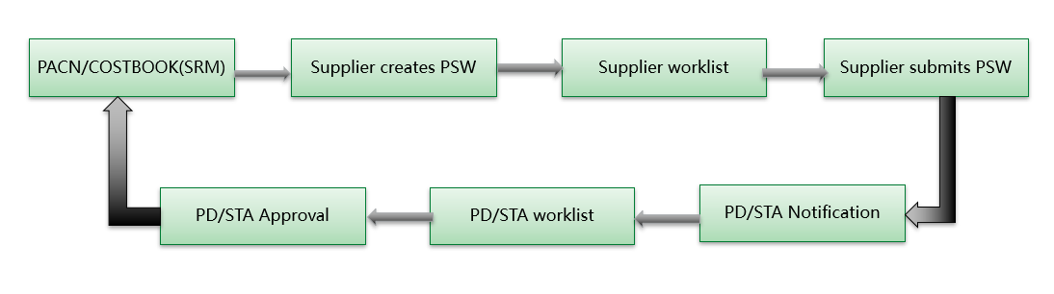

* The PSW consists of four sections:
  + PSW Form
  + Checklist
  + Attachments
  + Declaration
* All four sections require completion to successfully submit.
* There are 5 status of PSW: Draft, Submitted, Accepted, Rejected, InterimActive
* Draft: PSW has been created but not yet submitted
* Submitted: PSW has been submitted to CJLR for review
* Accepted PD: PSW has accepted by PD Engineer
* Accepted: PSW has been accepted by CJLR
* Rejected: PSW has been rejected by CJLR STA/PD Engineer
* InterimActive: Interim PSW has been accepted by JLR STA/PE Engineer

### Worklist

#### Work Step

##### **Worklist**

The My Worklist screen displays the PSWs that require your attention.

Clicking Worklist from My Menu. User is able to view all status PSW if there is any.

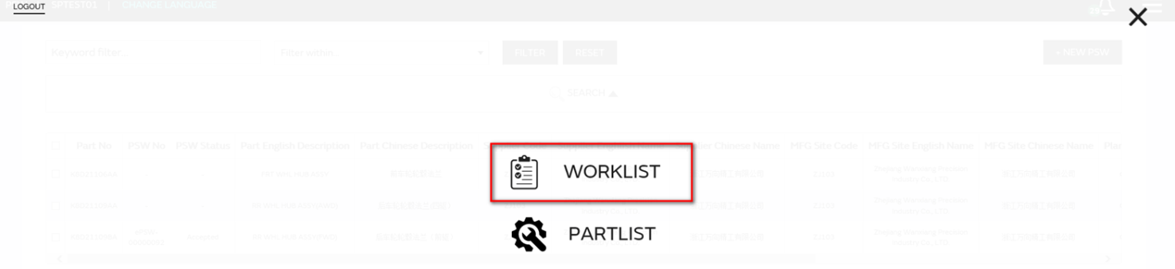

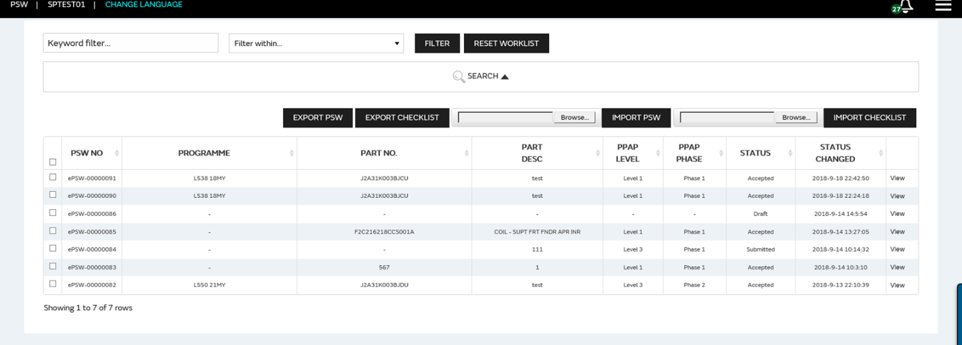

###### **PSW Quick Query**

* Only supports quick query of Program Name, Part no and Phase.
* First selects the required quick query condition, Input search criteria, Click FILTER Button, the PSW matched with the condition will display in the search result.
* Input search criteria, Click RESET WORKLIST Button, all inputted search criteria information will be cleared.



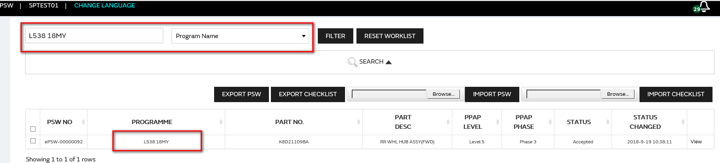

###### **PSW Query**

Click SEARCH① to expand the detailed query conditions:

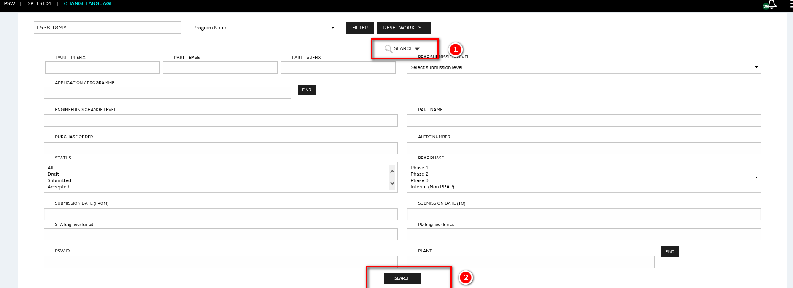

* Input search criteria, Click Search Button, the PSW matched with the condition will display in the search result.

###### **PSW View**

* From your Worklist, select the View hyperlink to open the PSW form.

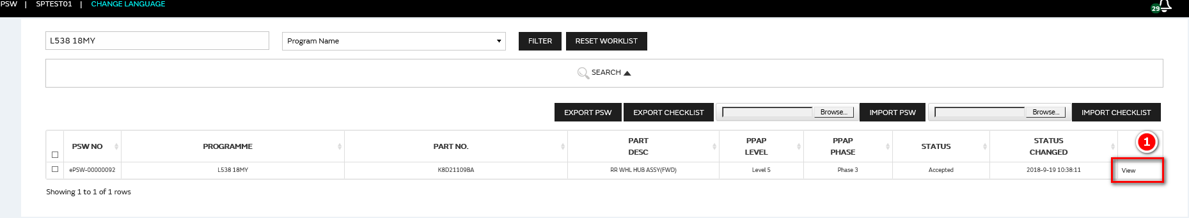

* The main components of the ePSW are as follows:

1. PSW Form
2. Checklist
3. Attchments
4. Declaration
5. Approval

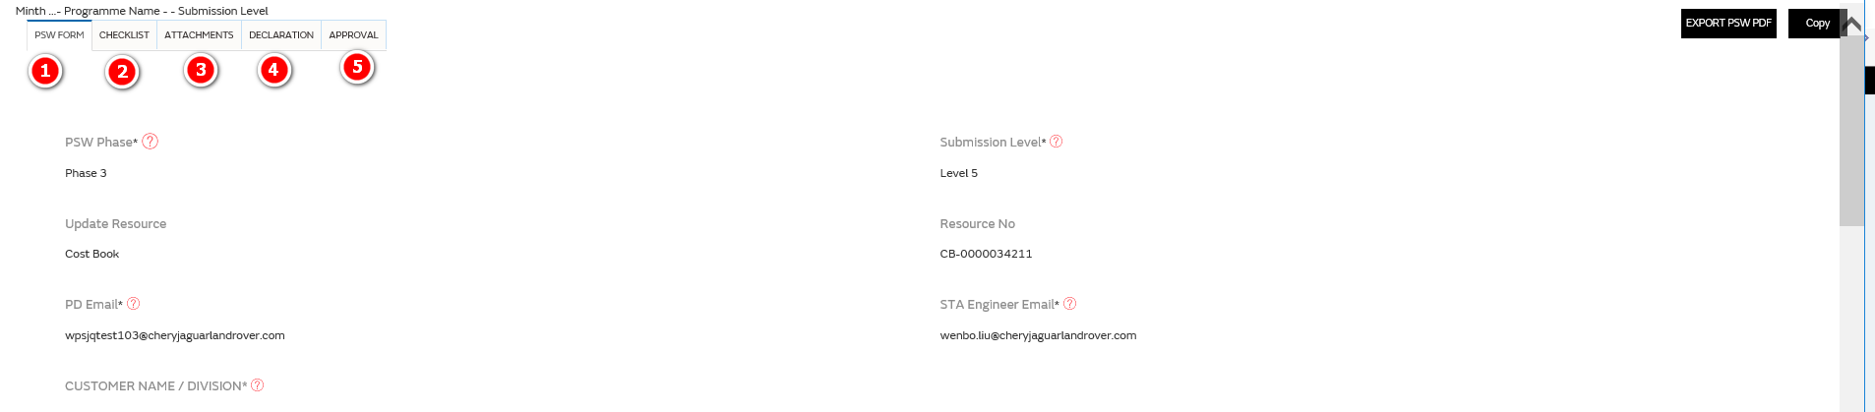

* On the details page, only the current PSW is in Draft status can be modified

###### **Export PSW Form**

* In the‘ WORKLIST’ list page, select the ePSW data to be exported, and click the Export PSW ② button

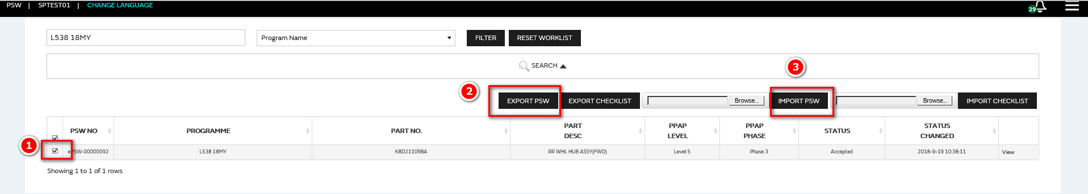

* The exported ePSW Form template is as follows (the red font represents mandatory fields) :

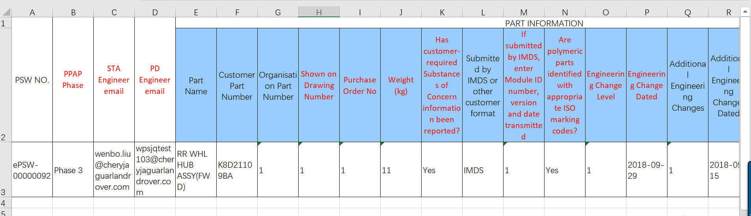

###### **Import PSW Form**

* In the‘ WORKLIST’ list page, select the ePSW data to be exported, and click the Import PSW③button



* The user can update the relevant data in ePSW in the exported EXCEL, and then click the button of "IMPORT PSW" to IMPORT the content of the PSW Form.

Note: when imported, the PSW NO in the file must already exist in the system.

###### **Export Checklist**

* In the‘ WORKLIST’ list page, select the ePSW data to be exported, and click the Export Checklist② button

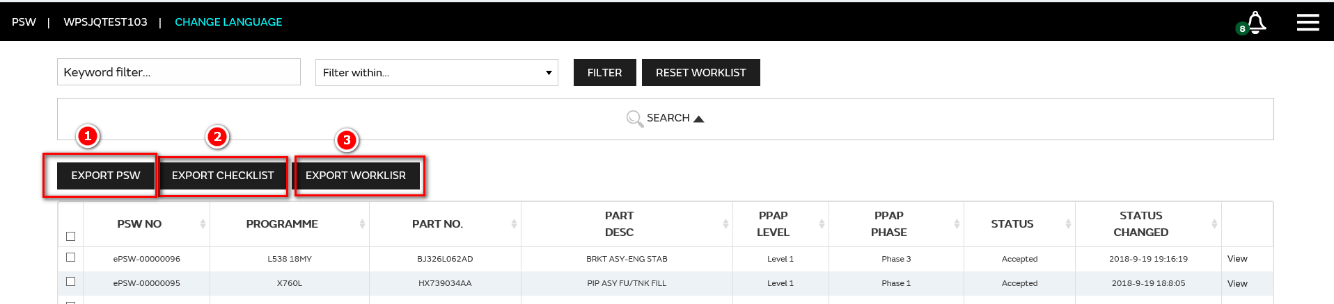

* The exported ePSW Checklist template is as follows (the red font represents mandatory fields) :

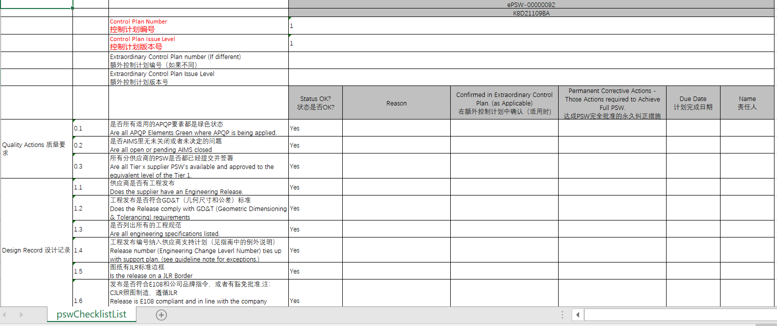

###### **Import PSW Checklist**

* In the‘ WORKLIST’ list page, select the ePSW data to be exported, and click the Import Checklist③button

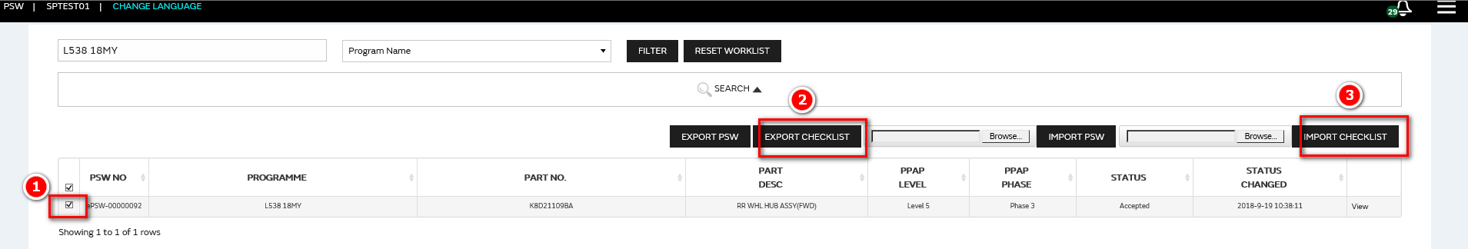

* The user can update the relevant data in ePSW in the exported EXCEL, and then click the button of "IMPORT PSW" to IMPORT the content of the PSW Form.
* Note: when imported, the PSW NO in the file must already exist in the system.

###### **Export Worklist**

* In the‘ WORKLIST’ list page, select the ePSW data to be exported, and click the Export Worklist③button



* The exported ePSW Worklist template is as follows:

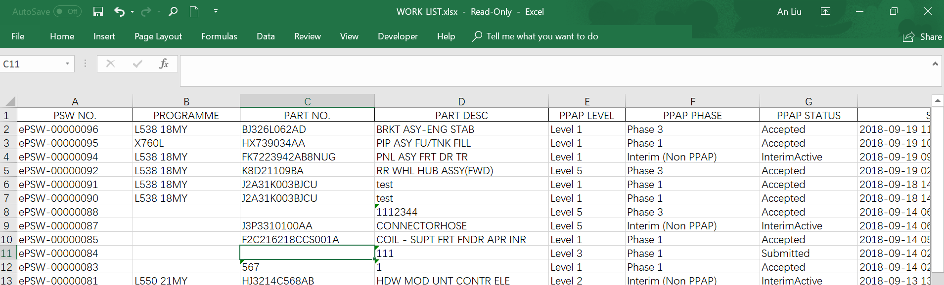

###### **Export PSW PDF**

* On the PSW details page, click the EXPORT PSW PDF button, Download ePSW in PDF format.

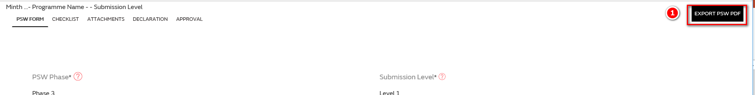

* PDF format as follow:

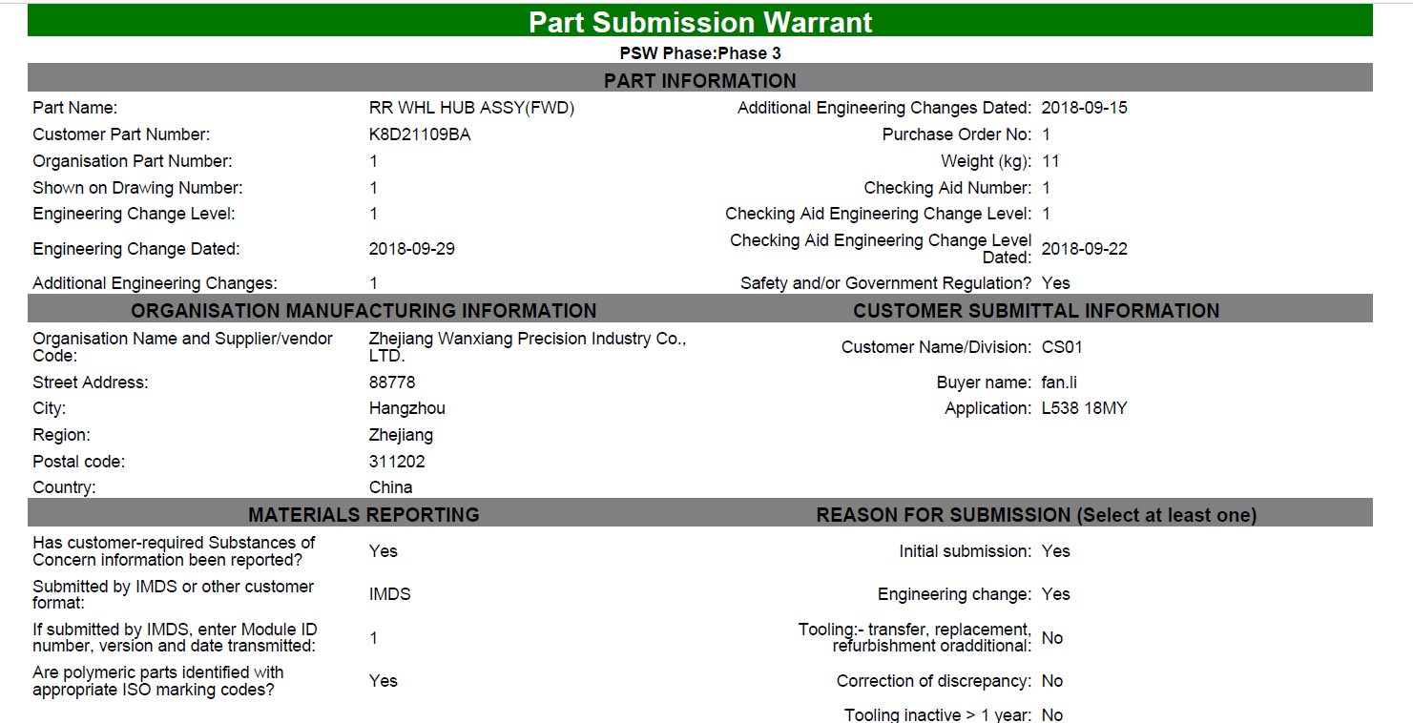

### Partlist

##### **Partlist**

* Clicking Partlist from My Menu. User is able to view all status Partlist if there is any.

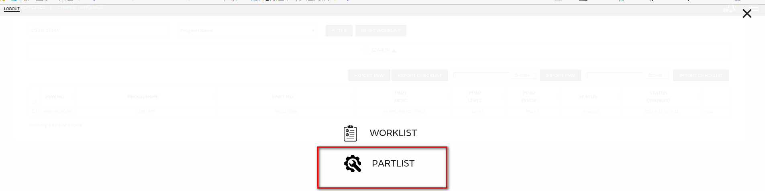

* Select 'Part list' and enter the Part list page:

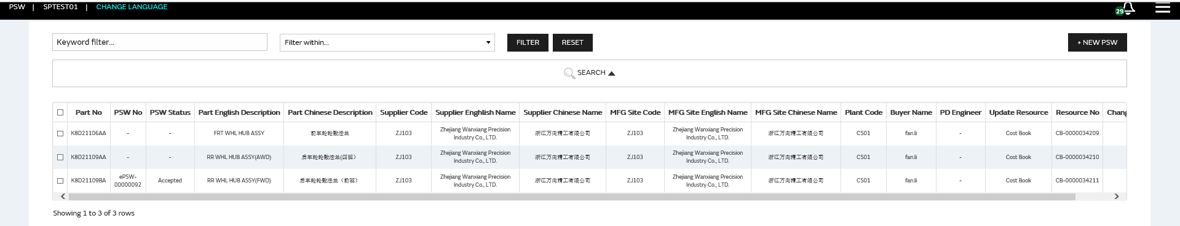

* There are 2 resource of Partklist: SRM COSTBOOK, SRM PACN

###### **Partlist Quick Query**

* Only supports quick query of Part no, Supplier code, Mfg Site code.
* First selects the required quick query condition, Input search criteria, Click FILTER Button, the PSW matched with the condition will display in the search result.
* Input search criteria, Click RESET Button, all inputted search criteria information will be cleared.



###### **Partlist Query**

Click SEARCH①to expand the detailed query conditions:

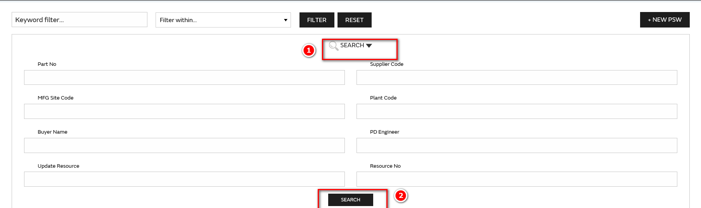

* Input search criteria, Click Search② Button, the PSW matched with the condition will display in the search result.

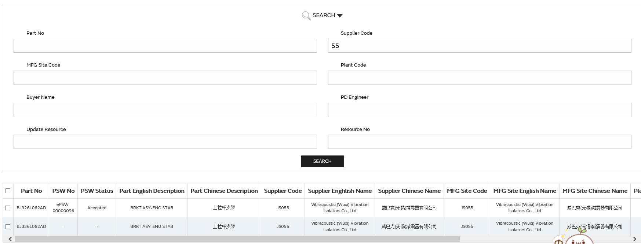

###### **Export Partlist**

* In the‘ Partlist’ list page, select the Part data to be exported, and click the Export PARTLIST button

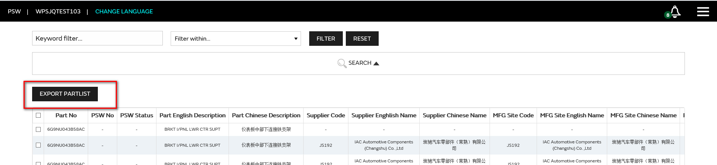

* The exported PARTLIST Form template is as follows:

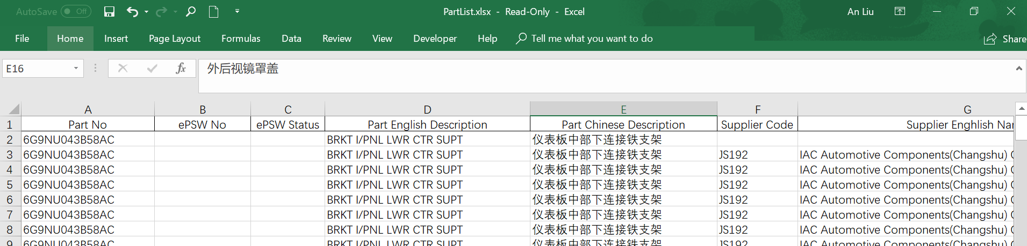

###### **New PSW**

* In the Part list interface, select the Part number that needs to be created for PSW, and click the button 'NEW PSW'
* In the ’New PSW’ page, Enter the following values to create a new PSW submission.

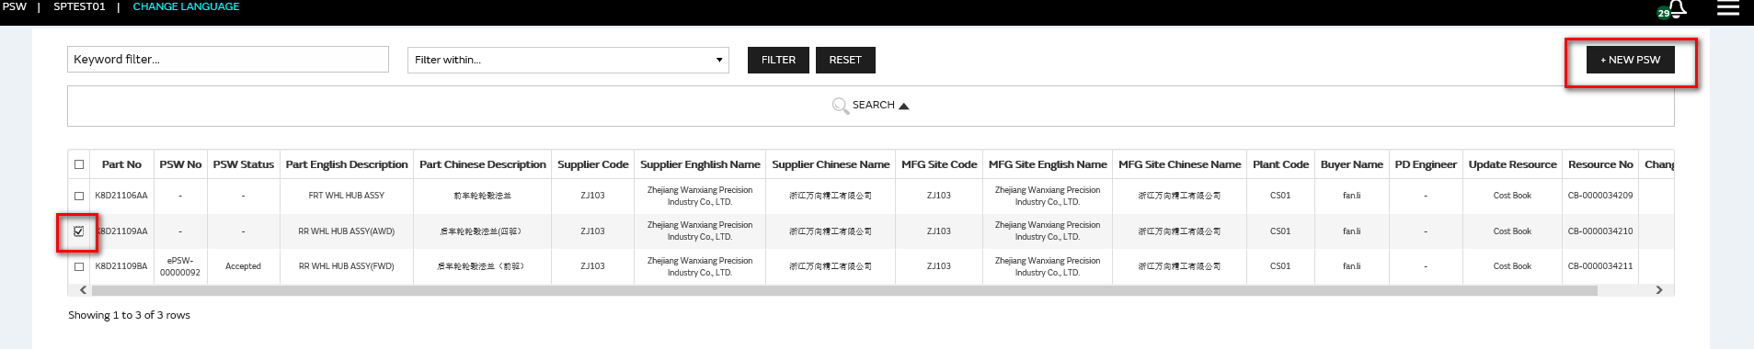

* **PSW FORM**

1. Select the **PPAP Phase**. Options are Phase 1, 2, and 3 and Interim (Non PPAP).
2. Select the Submission Level from the list of values. Options are Level 1,2,3,4 and 5.
3. Enter the **PD Engineer email** address. The postfix must be: @cheryjaguarlandrover.com. (Only applicable for PPAP Submission Level 5 and for ALL Interim PSW submissions)
4. Enter the **STA Engineer email** address. The postfix must be: @cheryjaguarlandrover.com. (Only applicable for PPAP Submission Level 2, 3, 4 and 5 and for ALL Interim PSW submissions).
5. Select the appropriate **Part Type**. The value determines how the user will enter part details and what validation will be performed by ePSW.

* Single: PSW covers a single part.
* Multiple: PSW covers multiple parts.
* CCR: PSW covers a Complex Commodity Release (also to be used for KSK).

1. Select the **Appearance Criteria (AAR)**.



1. Select the **Number of AAR files attached**.

Specify how many Appearance Approval Report files will be attached to the PSW

1. **Prefix, Base and Suffix:** This will be completed automatically from Partlist.
2. The **Part Name** is the Part Description. This will be completed automatically after the part number is entered.

Note: an XXXX error message indicates an invalid part number has been entered. Check that the part number matches that on the system.

1. Enter the actual **Weight** in kilograms to four decimal places.
2. Submission Results Note: you are required to answer Yes to all questions in the Submission results section. If any answers are No, an explanation must be entered in the Submission Result Explanation field.

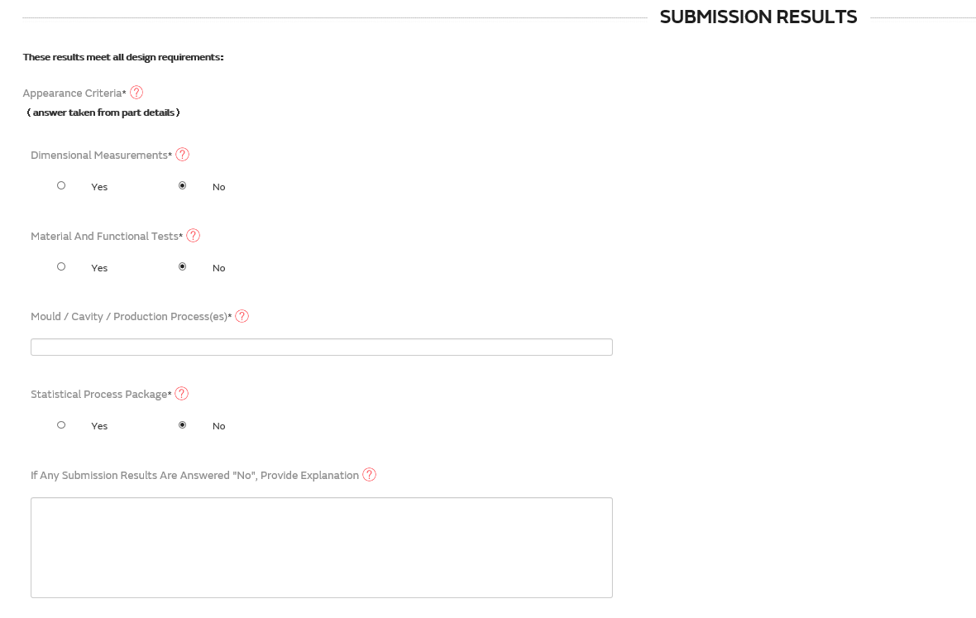

1. The Organisation Manufacturing Information is automatically completed based on your login details. Main field include: Code, Organisation name and supplier/vendor, Street address, City, Region, Post code, Country.
2. Select “Save” button to save PSW form information.

* **PSW Checklist**

1. Enter the Control Plan Number and Control Plan Issue Level.
2. Enter the Extraordinary Control Plan Number and Extraordinary Control Plan Issue Level where applicable.
3. All checklist items require a Yes , No or N/A answer in the **Status OK?** field.
   * If No is selected for any item, the PPAP Phase in the PSW form must be set to Interim PSW, otherwise an error message will display when you try to submit the PSW. For the most item which selected as ‘N/A’, system will skip the validation, except for the item 17.1.
   * 17.1 is Phase 3 PSW specific. If N/A selected for Phase 1 this will be OK, with reason added as above. But if No or N/A selected for Phase 3 PSW the system must recoganise this and flag an alarm. If the ‘N/A’ is selected, a comment is required.
   * All checklist items require Status OK to be set to Yes or No. An Interim PSW will have at least one item set to No.
   * If Supplier select N/A, system will skip the verification for this line item.
4. Select “Save” button to save check list information.

* **Attachments**

Ensure you have access to the files that you will need to attach.

1. the Appearance Criteria (AAR) question on the PSW form has been set to Yes. This triggers an AAR document attachment request in the Attachments section.
2. If it's an IPSW, the WERS Alert attachment must be uploaded
3. If it is PHASE 3, the CAR attachment must be uploaded
4. If CCR/KSK, CCR/KSK attachment must be uploaded

* **Approval**

The Approval section displays the PSW status change history. Here you can see when the PSW has been submitted / approved / rejected and by whom.

* **IPSW**

1. Select Interim (Non PPAP) for the PPAP Phase.
2. Enter the PD/STA Engineer email address.
3. All checklist items require Status OK? to be set to Yes /No/NA. An Interim PSW will have at least one item set to No.
4. Enter the WERS Alert Number
5. Enter a Description Summary
6. Attach a copy of the WERS alert and any other required documents.

* **CCR/KSK PSW**

1. Select CCR/KSK for the appropriate Part Type.
2. Prefix, Base and Suffix: When the Part Type is CCR, these fields are not validated.
3. Enter the Part Name. This must also be entered manually for CCR PSWs, so enter a suitable description of the part.
4. Must be added as an Attachment to the PSW.

###### **Delete/Save/Submit**

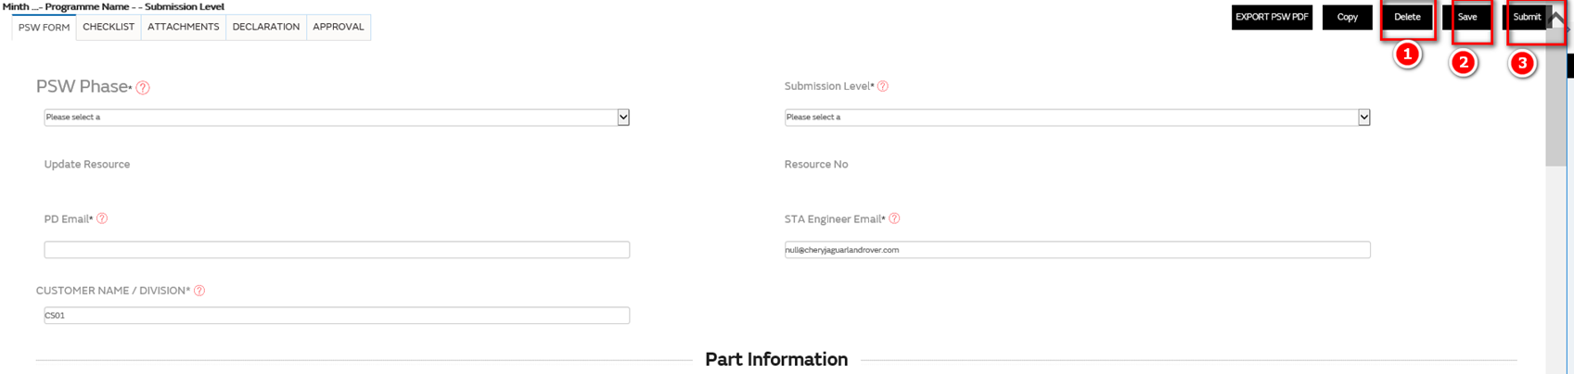

1. PSW in all Draft state can be deleted
2. After users fill in relevant information of PSW, click save to save the current input content.
3. After completing all information, click the Submit button to Submit the PSW.when submitting, the system will verify whether the content of PSW is entered correctly and completely. If not, it cannot be submitted successfully and the system will give corresponding prompt

### Notification

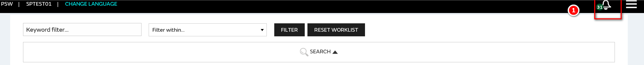

Click the ① icon to view the system message alerts:

The Notification page displays two tabs:

- **Today** displays notifications which are new today and have not been acknowledged

- **All** displays all notifications which have not been acknowledged

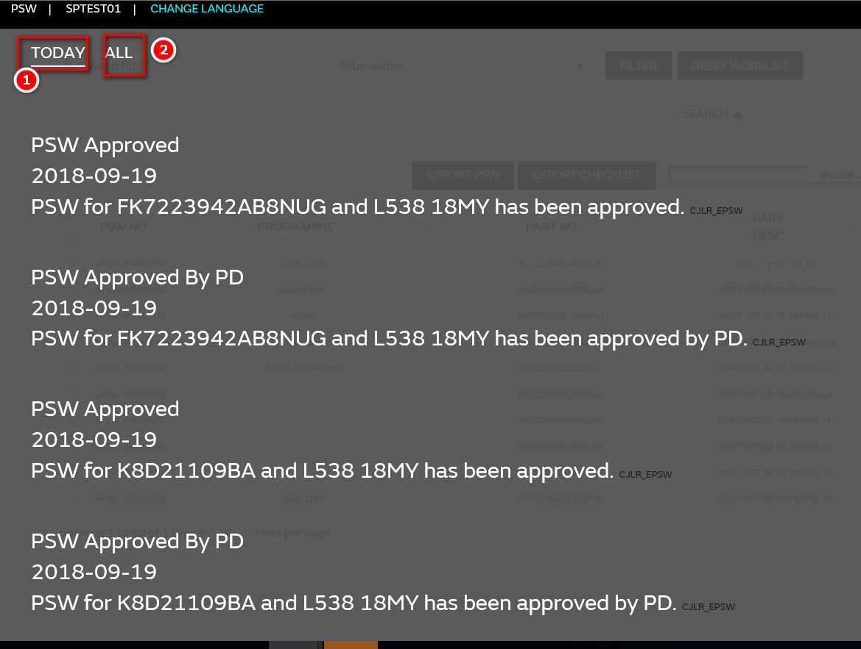

There will be message and email reminders for the following situations:

1. PSW submission

2. PSW approved

3. PSW's approval and refusal