Warranty Application User Manual

For Supplier

Business Process Procedure Summary Table

|  |  |
| --- | --- |
| **Process ID** |  |
| **Process name** |  |
| **Process steps** |  |
| **Frequency :** |  |
| **Performed by:** |  |
| **SAP transactions:** |  |
| **Sub Process:** |  |
| **Reference document** |  |

Document History

Revision History

|  |  |  |  |
| --- | --- | --- | --- |
| Version | Revision Date | Summary of Changes | Author |
| V 0.1 | 2015/05/11 | Write V0.1 | Vicky He |
| V 0.2 | 2015/06/16 | Add Liable Part | Vicky He |
| V 0.3 | 2015/07/03 | Add Pending Issue List, Settlement Management, Pickup Note Management | Vicky He |
| V 0.4 | 2015/08/05 | Update workflow for claim, settlement and Pickup Note | Vicky He |
|  |  |  |  |
|  |  |  |  |

Approved by

This document requires 1 or more of the following approvals:

|  |  |
| --- | --- |
| Name | Department |
|  | |
|  | |
|  | |
|  | |
|  | |

Content

Table of Contents

Content 4

1. Business Process Introduction 5

1.1 Purpose 5

1.2 Process Description 5

2. CJLR Portal CCR Solution Manual Detail 6

2.1 Purpose 6

2.2 Prerequisites or special case 6

2.3 Transaction Code 6

2.4 Work Step 6

2.4.1 Login 6

2.4.2 Pending Issue List 7

2.4.3 Claim Management 10

2.4.4 Settlement Management 15

2.4.5 PickUp Management 21

# Business Process Introduction

## Purpose

The purpose is to introduce the business process related to CJLR Warranty Application for Supplier .

## Process Description

Warranty Application provides claim query for Suppliers.

Supplier is able to query claim and history claim.

# CJLR Portal CCR Solution Manual Detail

## Purpose

The purpose of this user manual is to describe the function detail of Warranty Application. CJLR Supplier can take a reference.

## Prerequisites or special case

Claim messages have been imported from SAP to CJLR Portal.

WRLabel messages have been imported from SAP to CJLR Portal.

Part-Supplier Relationship messages have been imported from SAP to CJLR Portal.

Part Expense messages have been imported from SAP to CJLR Portal.

## Transaction Code

N/A

## Work Step

The following core functions are displayed

1. Login
2. Claim Management

### Login

1. Open IE11 and enter below URL:

<https://cjlr.portal.ap1.covapp.io>

1. Log in to CJLR Portal with Supplier account
2. Select CJLR Warranty in CJLR Application

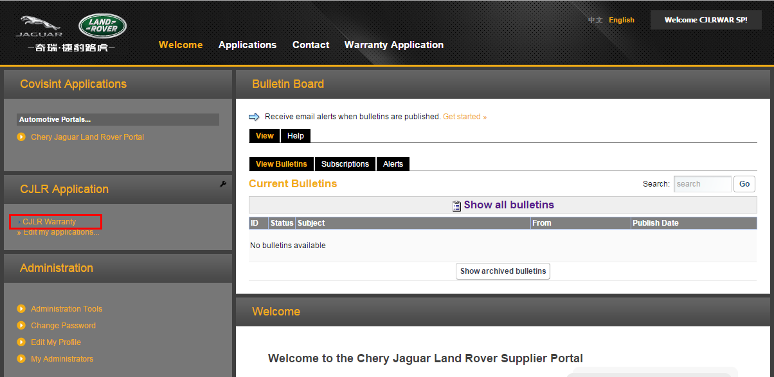

Warranty Application page is displayed

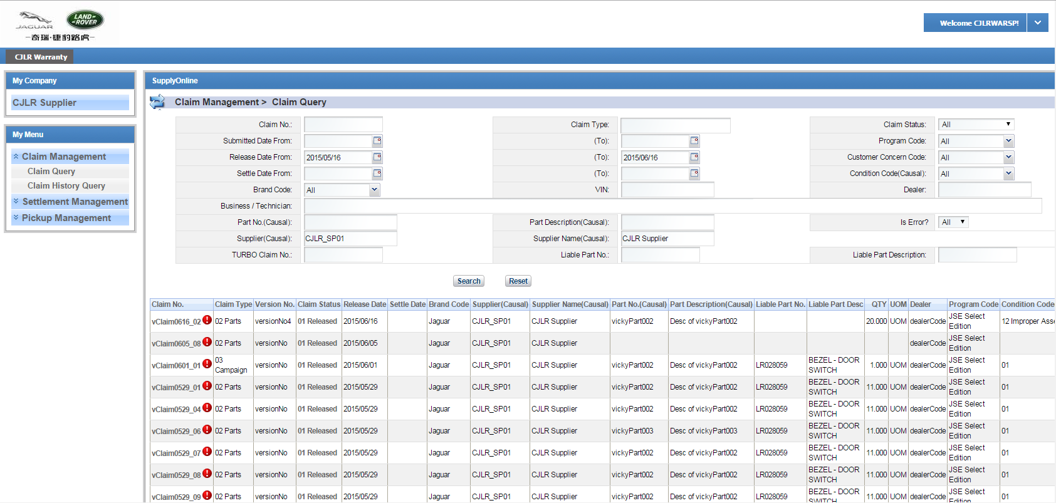

### Pending Issue List

User clicks supplier link in My Company portlet, Pending Issue List will be displayed. It displays -

* Confirm Settlement and the Number link
* Pending Settlement and the Number link
* Ready to Pickup and the Number link
* To be destroyed and the Number link

User can view pending issue detail via clicking the number link.

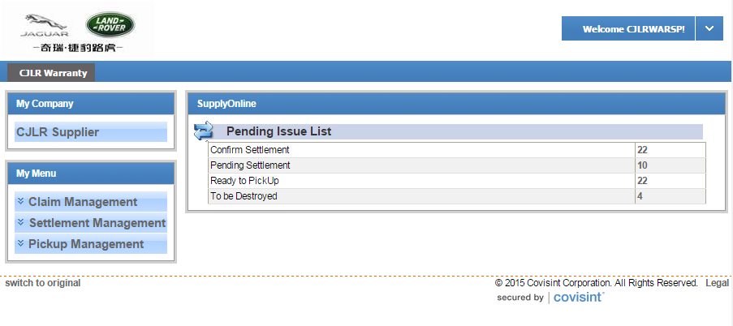

Click on the number link of Confirm Settlement, page navigates to Settlement Management >Settlement Query.Settlements which the status are 01 Released will be displayed in the searching result.

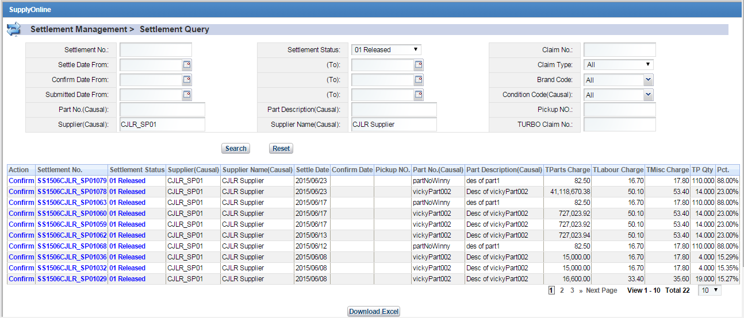

Click on the number link of Pending Settlement, page navigates to Settlement Management >Settlement Query.Settlements which the status are 03 Pending will be displayed in the searching result.

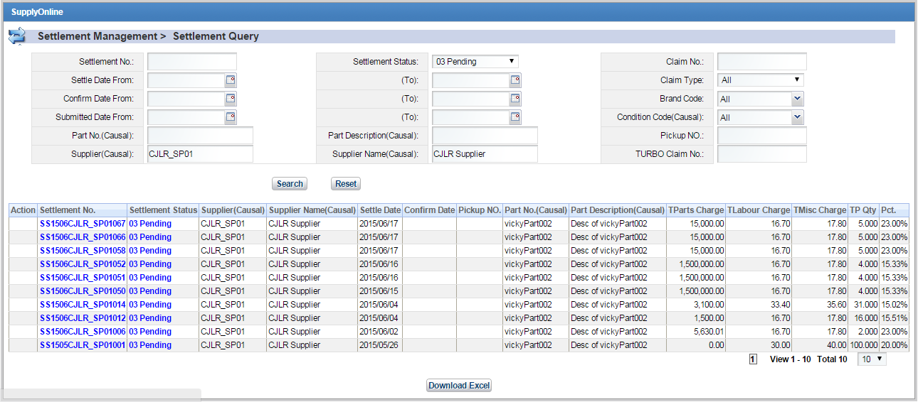

Click on the number link of Ready to Pickup, page navigates to Pickup Management >Pickup Note Query. Pickup notes which the status are 02 Confirmed will be displayed in the searching result.

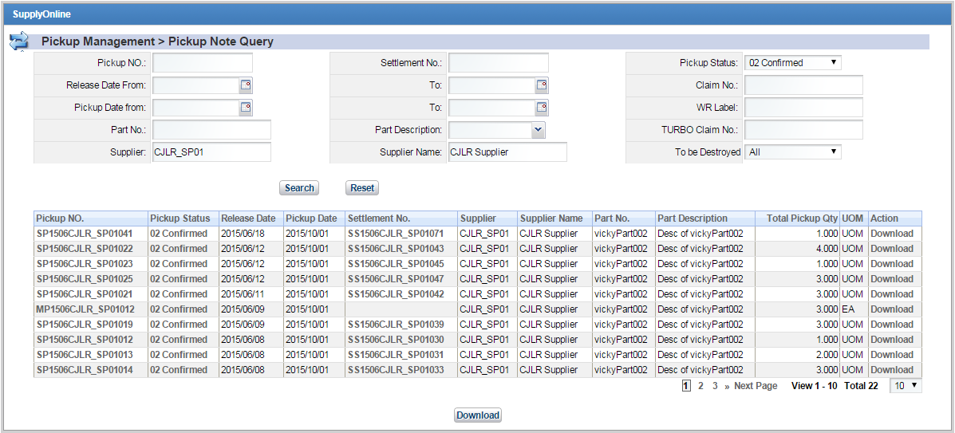

Click on the number link of To be destroyed, page navigates to Pickup Management >Pickup Note Query. Pickup notes which the status are 02 Confirmed and To be Destroyed = Y will be displayed in the searching result.

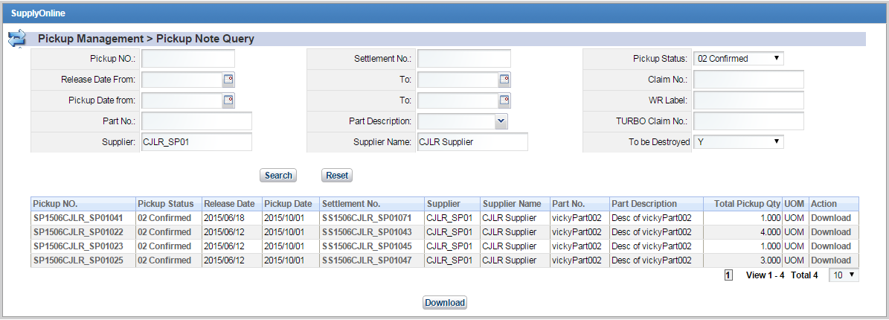

### Claim Management

#### Work Flow

There are 5 status of claim:

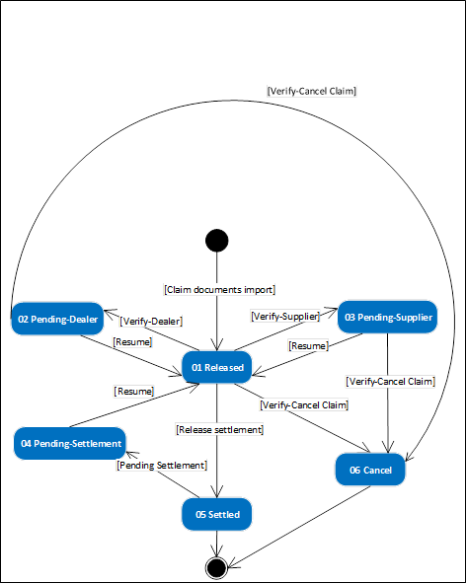

#### Work Step

##### Claim Query

Click Claim Management->Claim Query, and then go to Claim Query page. User can search and view the latest version of the claim.

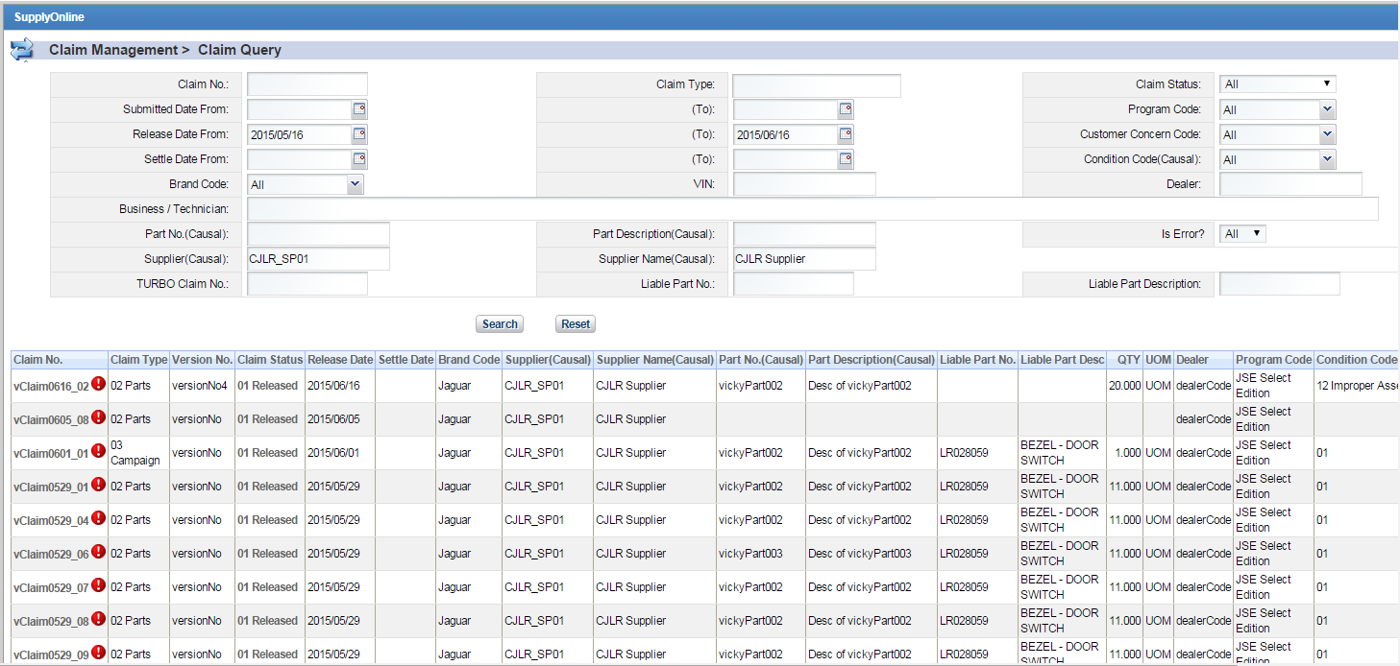

###### **Claim Query**

Enter search criteria. Click [Search] button, and the claim query list will display all related claim records based search condition. Click [Reset] button, it will resume the initial query condition.

Note: It will display "i" at right top side of "Claim No" column when claim has information. Click "i" icon, it will display detailed error window.

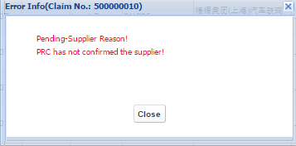

###### **Claim Download**

In claim query page, click [Download Excel] button or [Download Summary] button, the claims will be downloaded.

###### **Claim Detail**

In claim query page, select and click "Claim No" hyperlink of any record in claim query list, and then go to claim query detail page.

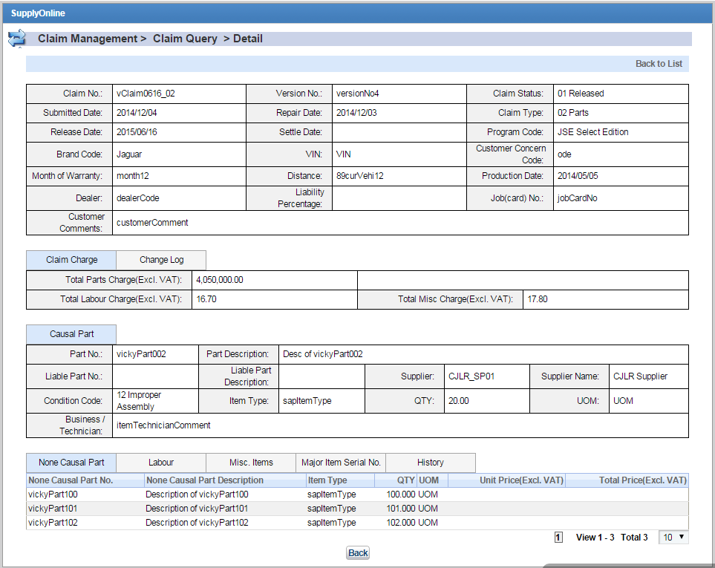

User can view claim detail info on this page.

Click “Change Log” tab beside “Claim Charge” tab, user can view claim change log.

Click “Labour” tab, user can view labour info.

Click “Misc.Items” tab, user can view miss item info.

Click “Major Item Serial No.” tab, user can view major item info.

Click “History” tab, user can view claim log.

Click “Back to List” link, page goes back to claim query page.

##### Claim History Query

Click Claim Management->Claim History Query, and then go to Claim History Query page. User can search and view history version of the claim.

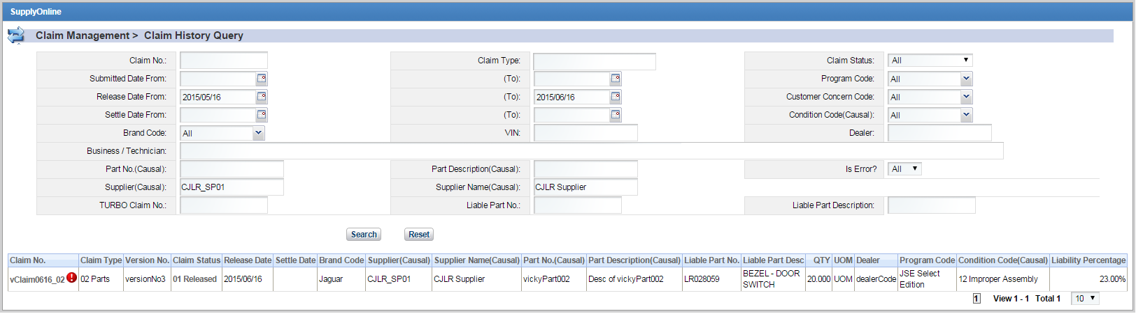

###### **Claim History Query**

Enter search criteria. Click [Search] button, and the claim history query list will display all history claim records based search condition. Click [Reset] button, it will resume the initial query condition.

Note: It will display "i" at right top side of "Claim No" column when claim has information. Click "i" icon, it will display detailed error window.



###### **Claim Detail**

In claim history query page, select and click "Claim No" hyperlink of any record in claim history query list, and then go to claim query detail page.

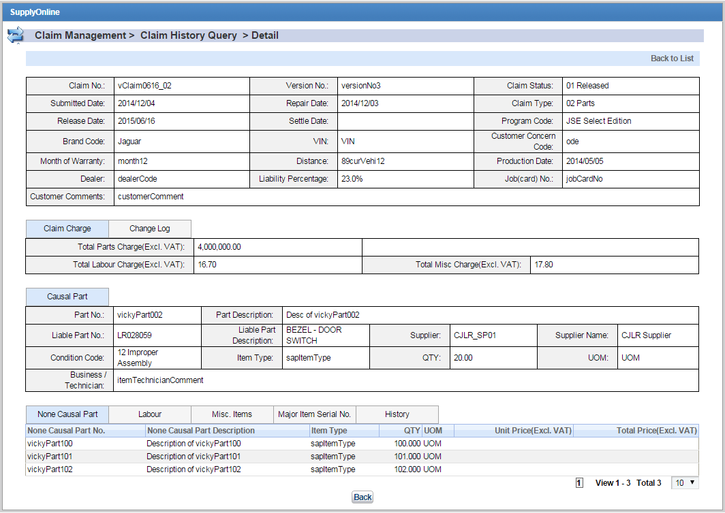

User can view claim detail info on this page.

Click “Change Log” tab beside “Claim Charge” tab, user can view claim change log.

Click “Labour” tab, user can view labour info.

Click “Misc.Items” tab, user can view miss item info.

Click “Major Item Serial No.” tab, user can view major item info.

Click “History” tab, user can view claim log.

Click “Back to List” link, page goes back to claim query page.

### Settlement Management

#### Work Flow

There are 2 types of settlement:

1. Settlement generated by System
2. Settlement created by CJLR User

There are 3 status of the Settlement: 01 Released，02 Confirmed，03 Pending. Blow diagram shows the conversion:



Workflow of the Settlement shows as below:



1. Settlement generated by System

Settlement will be generated automatically on the first day of each month based on Part No. (Causal) + Supplier. The preconditions should be: 1. Status of the claim is 01 Released. 2. Publish date of the claim should be current month – 2 or before. 3. No alert for the claims. The id of the settlement is SS + MMYY (4) + supplier code (5) + serial number (3). Status of the settlement is 01 Released. At the same time, related claim changes from 01 Released to 05 Settled.

2. Settlement created by CJLR User

CJLR User can create the settlement manually based on those claims which do not exist in System. The id of the settlement is MS + MMYY (4) + supplier code (5) + serial number (3). Status of the settlement is 01 Released.

Supplier can confirm both 2 types of settlement within 21 days after it is generated or created. Otherwise, it will be confirmed automatically by system. Once confirmed, the status of the settlement will be 02 Confirmed.

Recovery user can pending the settlement with status 01Released and the status will change to 03 Pending. At the same time, related claims will change form 05 Settled to 04 Pending-Settlement.

#### Work Step

* + - * 1. Settlement Query

Settlement Management-> [Settlement Query](http://10.69.2.99:8080/web/guest/cjlr-warranty?p_p_id=portletsupplychain_WAR_sosupplychainportlet_INSTANCE_lvWRw24sTMGl&p_p_lifecycle=0&p_p_state=normal&mainAction=claimSettlementQuery&divId=menu1Child&isVisiable=true) .Enter query string click Search button. The expected result displays.

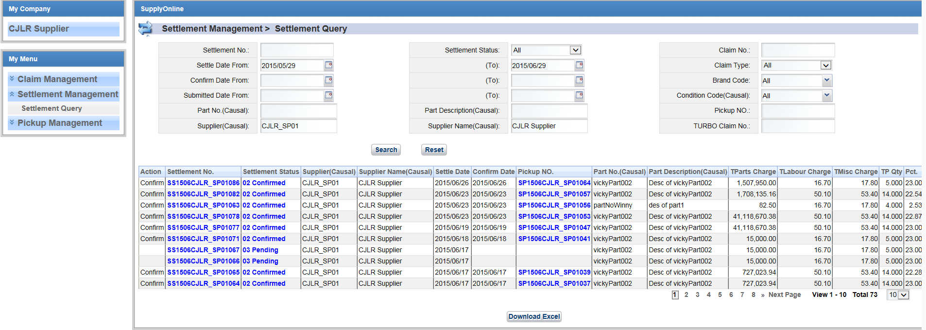

* + - * 1. Settlement Query  > Detail

On settlement Query result page click the hyperlink of the settlement  then the  Detail page displays.

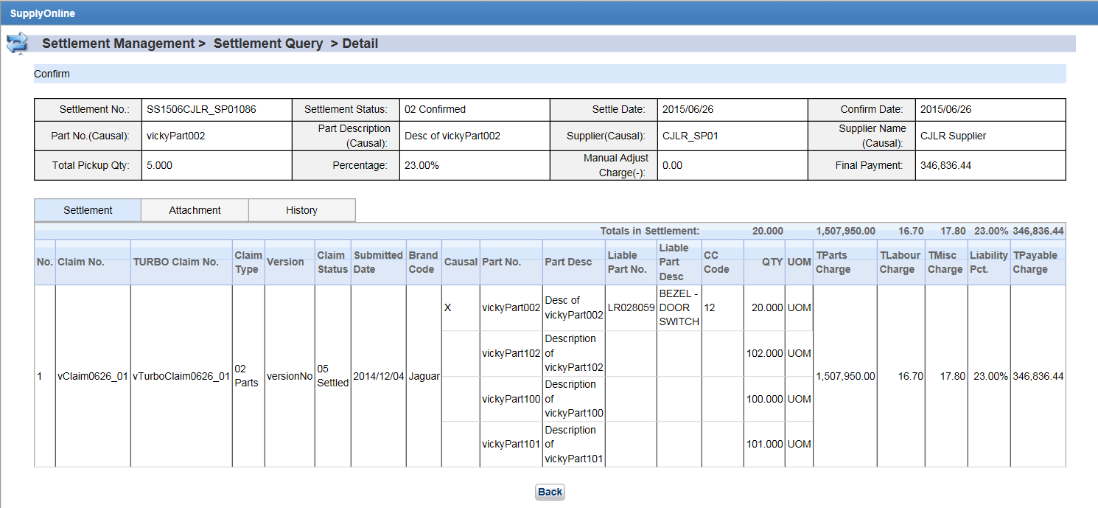

PS：

1. No confirmed date for 01 Released settlement but for 02 Confirmed settlement.
2. Total Parts Charge in Claim = partPurchaseAmount sync with SAP* Percentage；Claim type:"03-Campaign"，Percentage =1.6；Other type Percentage =1.5
3. Total Payable Charge in Settlement： （Total Parts Charge in Claim + Total Labour Charge + Total Misc Charge） * Liability Percentage.
4. Settlement detail：
5. Total Causal Qty in Settlement = Sum(Total Qty in Claim)
6. Total Parts Charge in Settlement = Sum(Total Parts Charge in Claim)
7. Total Labour Charge in Settlement = Sum(Total Labour Charge in Claim)
8. Total Misc Charge in Settlement = Sum(Total Misc Charge in Claim)
9. Total Payable Charge in Settlement = Sum(Total Payable Charge in Claim)
10. Liability Percentage = Total Payable Charge in Settlement / (Total Parts Charge in Settlement + Total Labour Charge in Settlement + Total Misc Charge in Settlement)
11. Settlement header：
12. Total Payable Charge in Settlement = Sum(Total Payable Charge in Claim)- Manual Adjust Charge(-)
13. Liability Percentage = Total Payable Charge in Settlement / (Total Parts Charge in Settlement + Total Labour Charge in Settlement + Total Misc Charge in Settlement
14. Total Pickup Qty：Qty(Causal) in Settlement *Percentage in header
    * + - 1. View settlement History

There are 2 method of View settlement History

i：On settlement Query result page click the hyperlink of the settlement status.

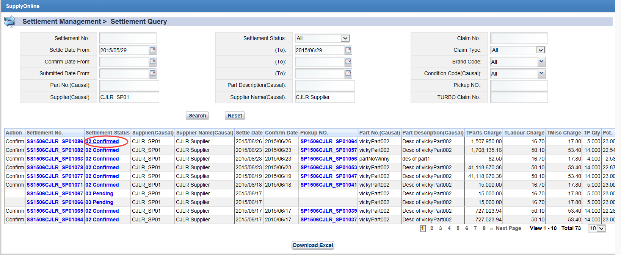

ii：On settlement detail page click the History tab.

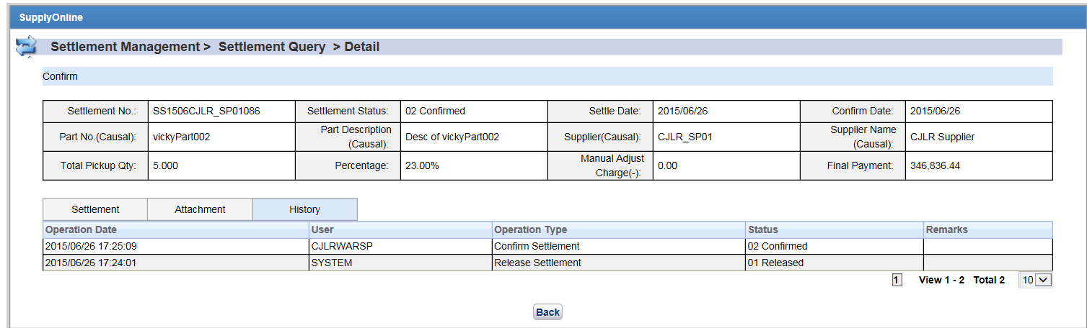

The history detail ：Operation Date，User，Operation Type，Status，Remarks

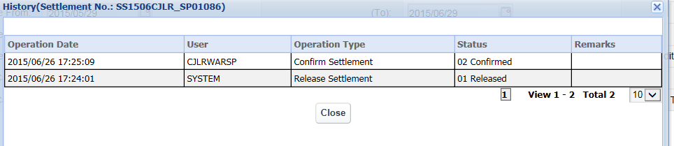

* + - * 1. View attached

On settlement detail page click the Attached tab.

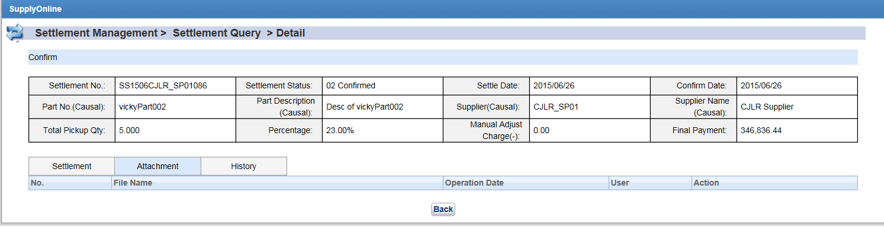

* + - * 1. Download Settlement

On settlement Query result page click Download Excel button 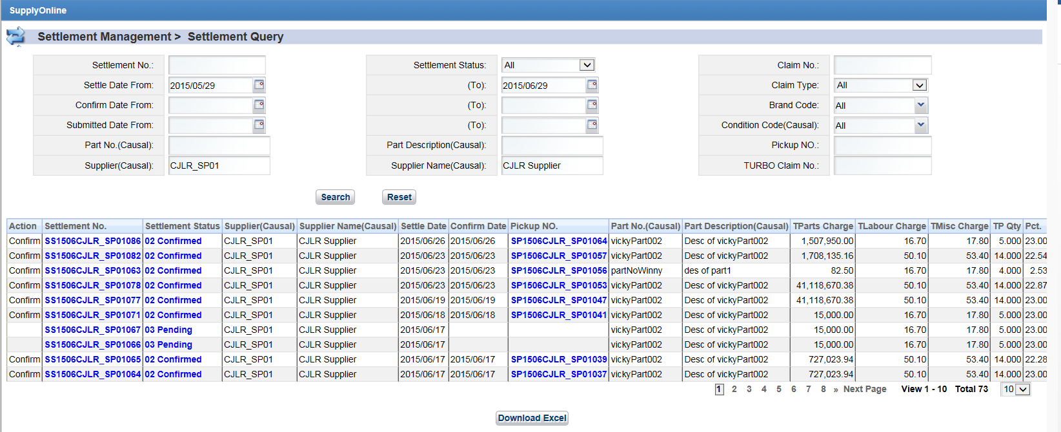

Open the download settlement. The first sheet display the total settlement. The other sheets display each settlement detail.

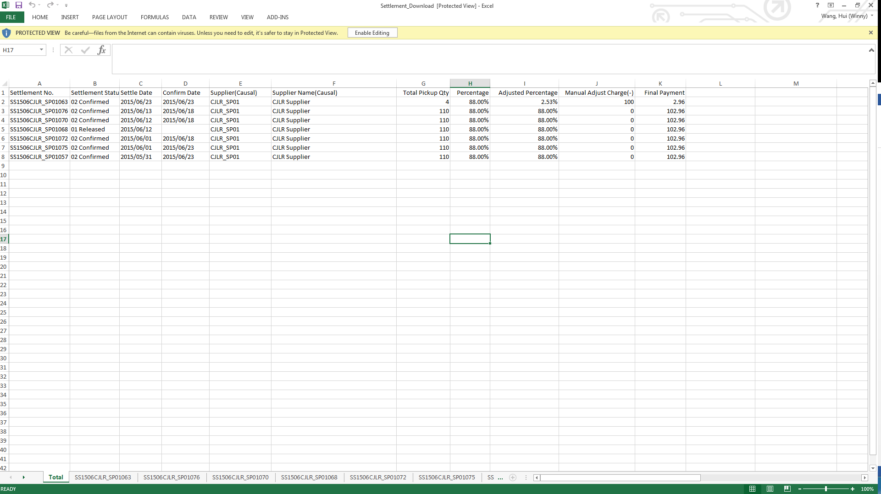

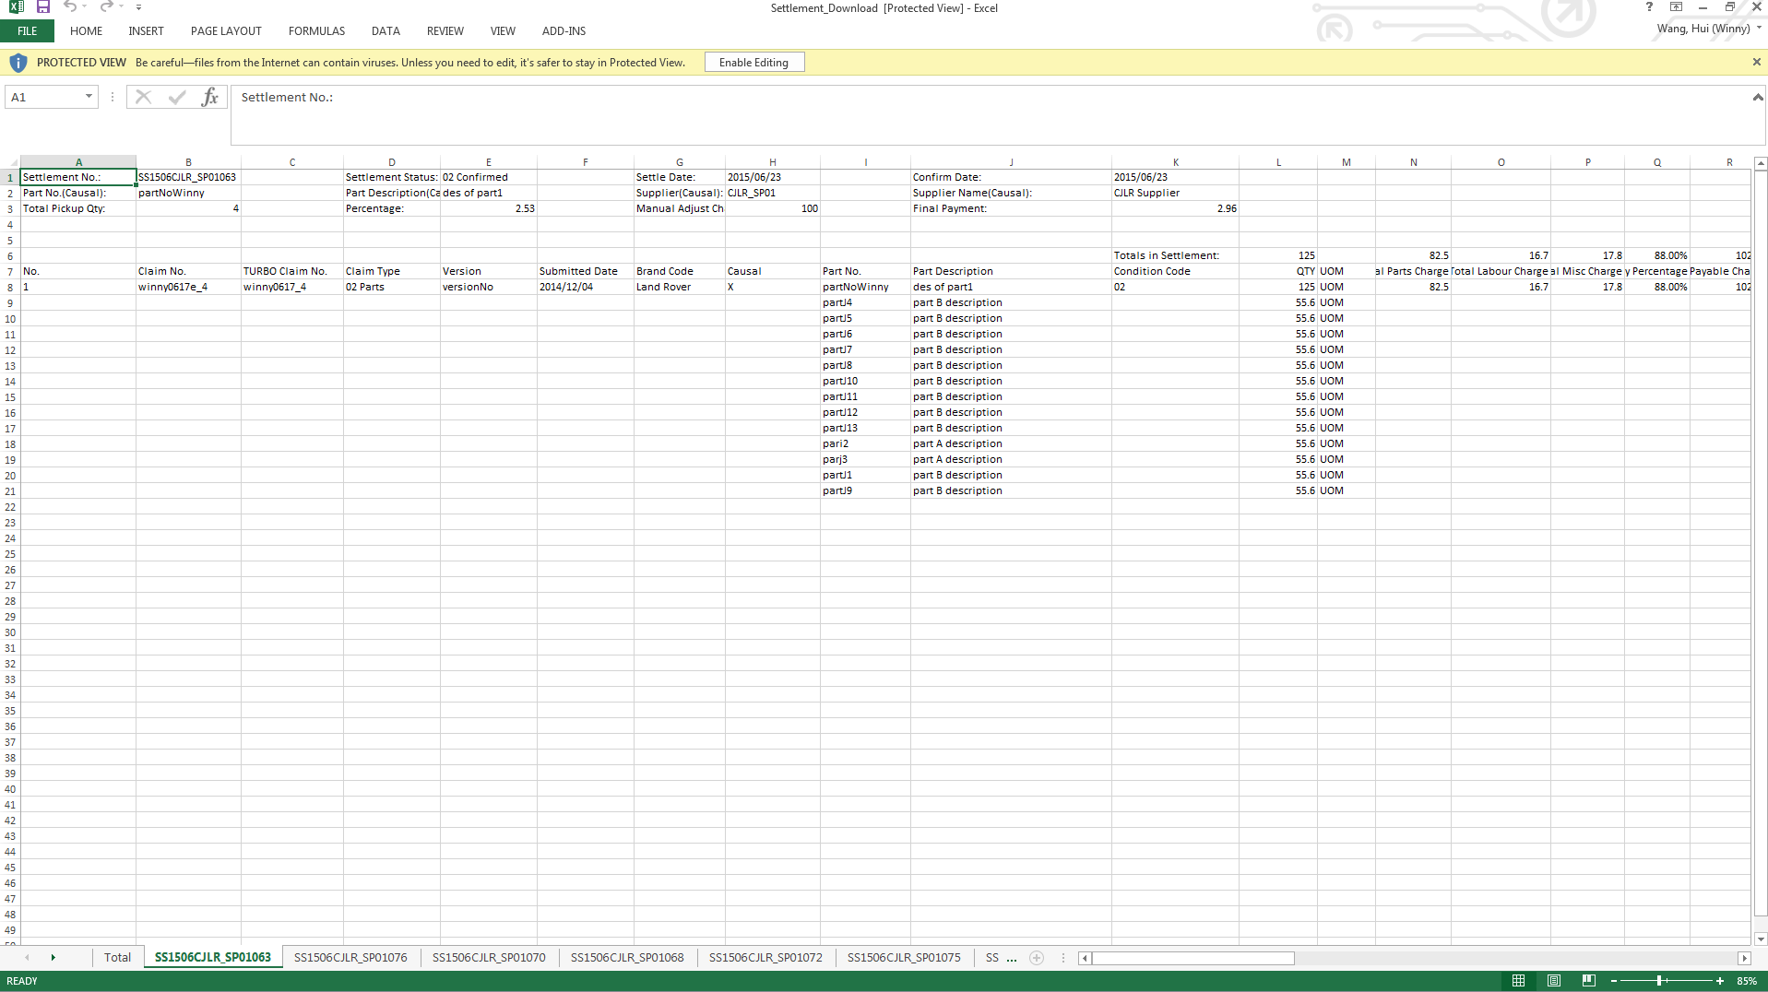

* + - * 1. confirm settlement

The settlement with status 01 Released can be confirmed by supplier by click the confirm link.

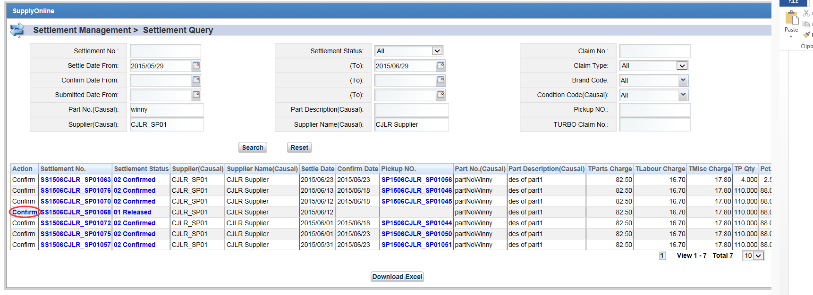

Type the Remarks and click Yes button then success alert displays.

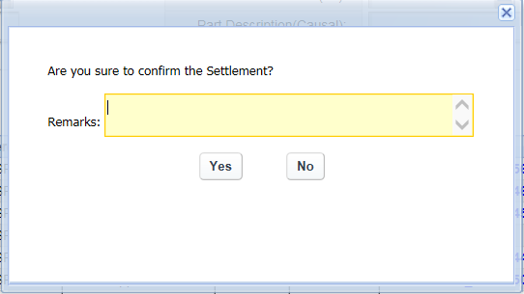

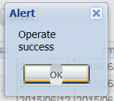

Click OK button, the settlement status change to 02 Confirmed.

### PickUp Management

#### Work Flow

There are 3 types of Pickup note:

1. Pickup note which is created via WRLabel. There is no corresponding settlement in system.
2. Pickup note which is generated automatically by system. There is one to one correspondence with the settlement which is generated automatically.
3. Pickup note which is created manually based on the settlement which is created manually.

There are 3 status for the Pickup note：01 Released, 02 Confirmed. Conversion is as below:

1. Pickup note which is created via WRLabel.



Recovery user can create pickup note by selecting WRLabel. The id of the pickup note is: IP + YYMM (4) + supplier code (5) + serial number (3). If the status of the WRLabel are all 123 or z02, the status of the pickup note is 02 Confirmed.

If the WRLabel are not 123 or z02, the status of the pickup note is 01 Released. Once the status of the WRLabel changes to 123 or z02, the status of the pickup note is 02 Confirmed. Or SAP send pickup return message to SP, the status of the pickup note is 02 Confirmed. The pickup quantity is the quantity of the selecting WRLabel. Pickup return message which SAP send to SP also includes pickup date and outbound delivery number. If the pickup quantity in return message does not equal the pickup quantity in SP, there will be an alert against the pickup note.

1. Pickup note which is generated automatically.



After the settlement (settlement which is generated automatically) is confirmed by Supplier or System, and the pickup quantity > 0 in the settlement, the Pickup note will be generated automatically. The id of the pickup note is SP + YYMM(4) + supplier code (5) + serial number (3). The status of the Pickup note is 01 Released. Pickup quantity of the Pickup note is quantity in settlement – WRLabel quantity. Thus pickup quantity may > 0, = 0 or < 0. But Supplier can only view the Pickup note which pickup quantity is more or equals 0.

After the Pickup note is confirmed which means SAP send message to SP, the status of the Pickup note changes to 02 Confirmed. Pickup quantity is always the calculated quantity in SP. If pickup quantity in return message changes, there will be an alert against the pickup note. The return message also includes pickup date and outbound delivery number.

1. Pickup note which is created manually based on the settlement which is created manually.



Recovery User can create Pickup note manually based on the settlement which is created manually also. The id of the pickup note is MP + YYMM(4) + supplier code(5) + serial number (3). Once the pickup note is created, the status is 02 Confirmed.

#### Operation Steps

##### Pickup note Query

Click PickUp Management 🡪Pickup note Query, enter search criteria and click Search button. Searching result will be displayed.

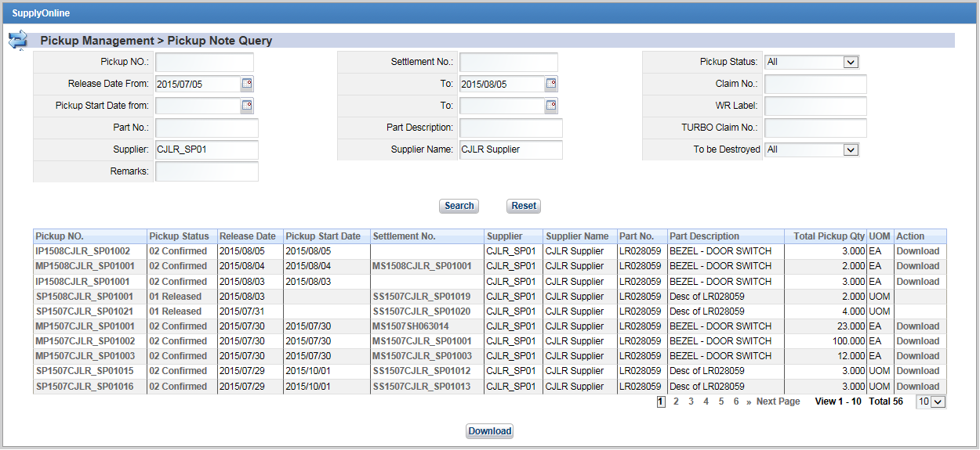

##### View PickUp Detail

Click PickUp No. link in searching result, page navigates to PickUp detail page.

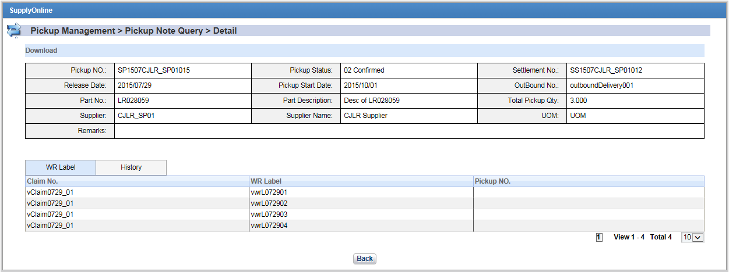

Note:

1. Pickup date is empty if the status of the Pickup note is 01 Released. For PickUp which the status is 02 Confirmed, it has pickup date and out bound delivery number.
2. Pickup note which is created by WRLabel has NO settlemnt number. Pickup note which is created automatically has settlement number.
3. There are 2 types of WRLabel in WRLabel tab. One is selected when creating Pickup note via WRLabel. Another is specified in message which SAP send to SP.

For the first type of WRLabel, related claim and pickup No. will be displayed.

For the second type of WRLabel, related claim will be displayed but pickup No. will not be displayed.

##### View History Log of the Pickup note

There are 2 ways to view history log of the Pickup note:

1. Via Pickup note detail page 🡪 History tab

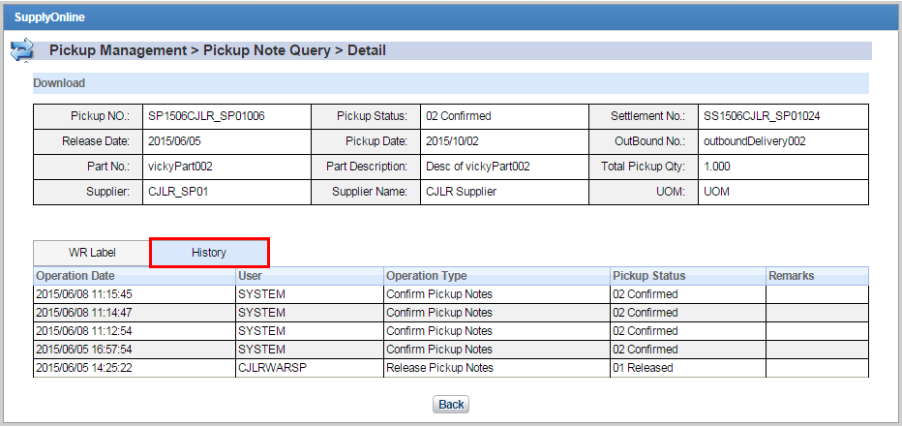

2．Via Pickup note searching result 🡪 PickUp Status link

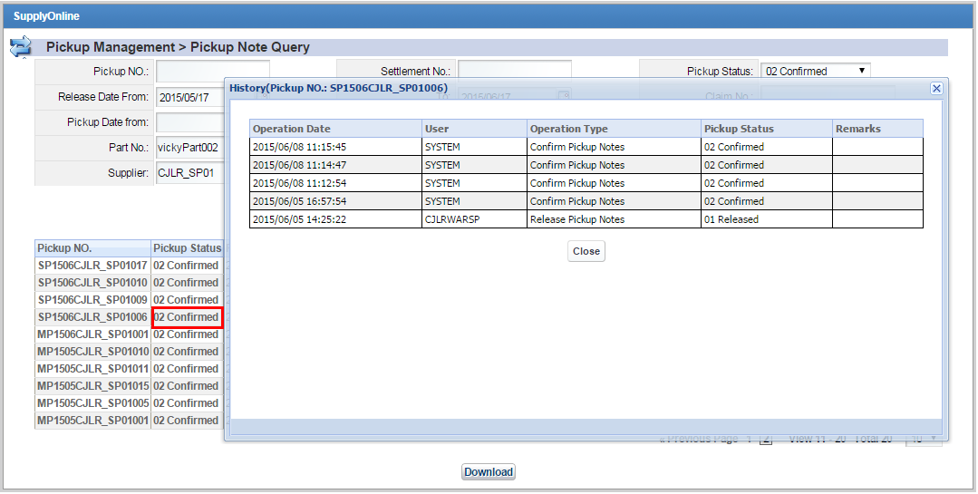

##### Dowload Pickup note in PDF

User can download Pickup note in PDF, but only for 02 Confirmed ones. Search Pickup note which status is 02 Confirmed in Pickup note Qyery page. Click on Download button. A dialog box will be popped up asking user if he/she wants to open or save it. Save or open the PDF. PDF is like below:

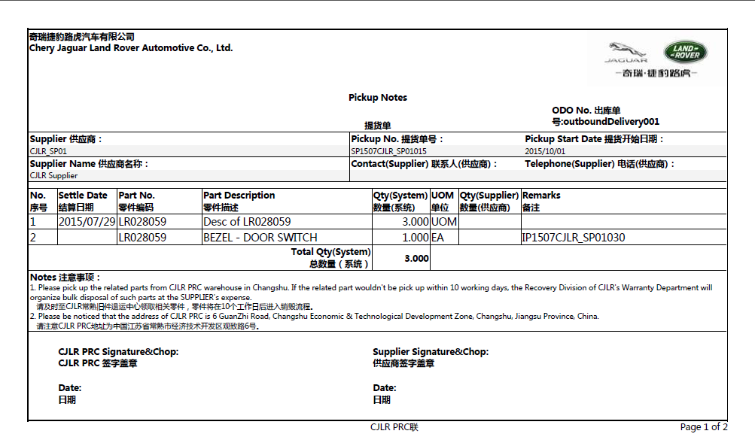

##### Download Pickup note in Excel

User can download Pickup note in Excel after query. The Excel includes pickup note list and pickup note detail.

Search PickUp note then click on Download button. A dialog box will be popped up asking user if he/she wants to open or save it. Save or open the Excel. Excel is like below:

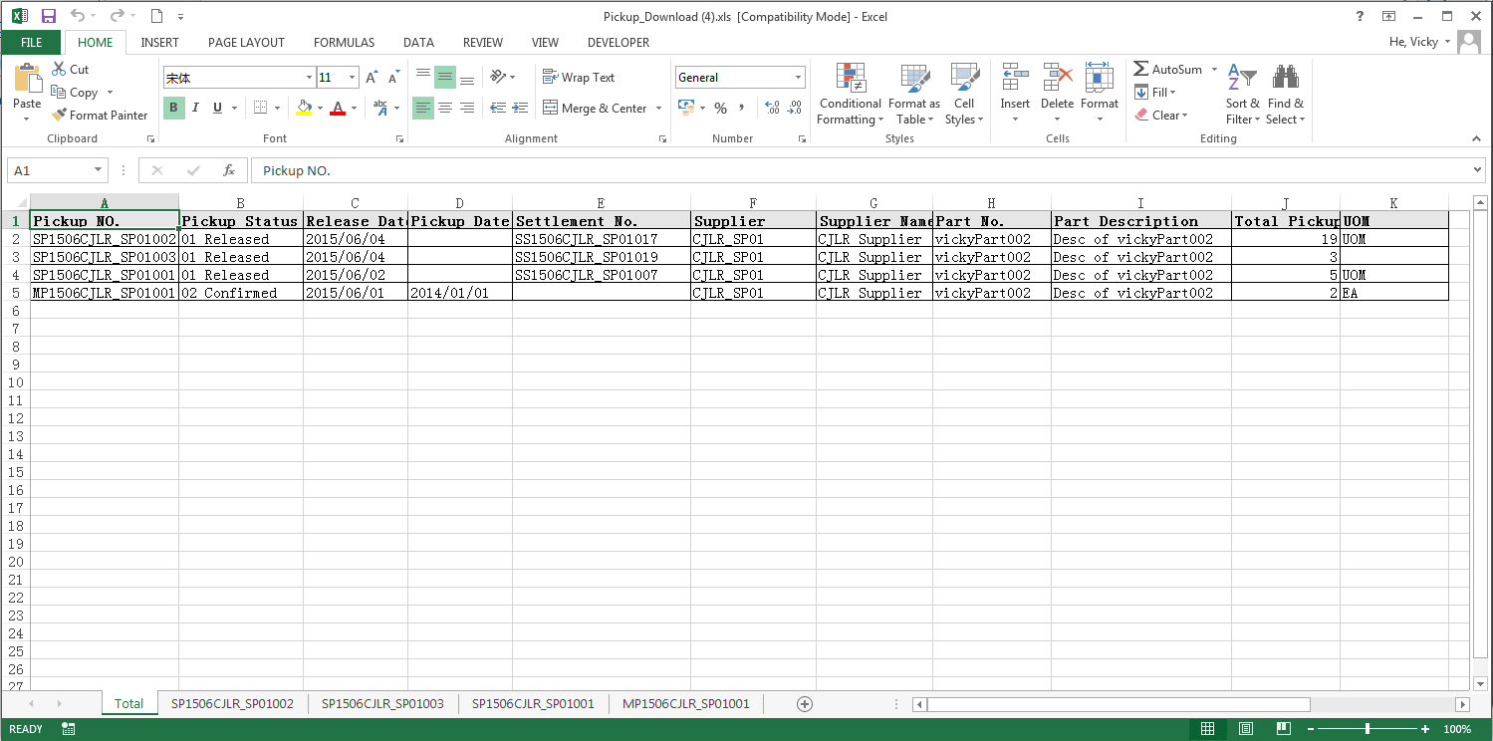

Total spreadsheet displays the Pickup note list. Click on Pickup No. spreadsheet, it displays the Pickup note detail. Like below:

